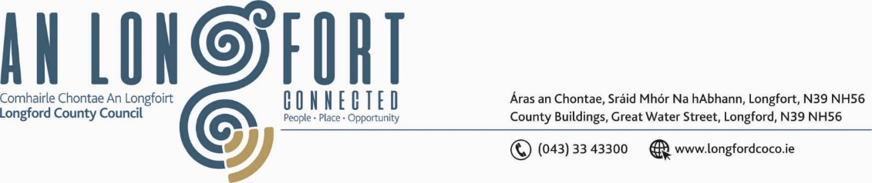

***BALLYMAHON MUNICIPAL DISTRICT***

***Please note meeting will be held in Ballymahon Library.***

**16 May 2024**

**To: Each Member of Ballymahon Municipal District.**

**Dear Member,**

You are requested to attend a Meeting of Ballymahon Municipal District to be held

**in Edgeworthatown Library** on **Thursday 23 May 2024 at 10:30am** to transact business, as set out on the agenda hereunder.

**Yours sincerely**,

_______________

**Claire McNabola,**

**Meetings Administrator.**

**AGENDA**

Prayer before meeting.

1. Confirmation of Minutes
2. Ballymahon Municipal District Meeting held on the 28 May 2024 – enclosed.
3. Ballymahon Municipal District Committee Meeting held on the 28 May 2024 – enclosed.

**2.** Matters arising from Minutes

**3.** Declaration of Interest by Members

**4**. Management Report – enclosed

**5.** Ardagh Clock Tower – Presentation

**6.** Community Grants

**7**. Part 8 – Pobal Le Cheile

**8**. Notices of Motions, submitted by Councillors, as listed hereunder –

**Councillor Paul Ross**

1. That Longford Co Council carry out an upgrade to the pedestrian crossing lights at Mercy Secondary School, Main St, Ballymahon
2. That Longford Co Co Review the speed limit at the Moor Ardagh on the R393 and reduce to a 50KM limit at the Football pitch in the interest of public safety.
3. That Longford Co Co introduce a solid white line on the R393 on the approach to Carrickboy from Ballycloughan

**Councillor Pat O’Toole**

1. I call on Longford County Council to carry out a low-cost safety scheme at the junction of the  L1133 and the L1130 at Shrule Junction to improve the sight lines and in the interest of public safety
2. I call on Longford County Council to assess the feasibility of putting a footpath in place from the Silver Birches Estate to Young Grattans GAA grounds at Dunbeggan Longford.